HTML List Elements

📘 Definition
# Source: AI Source: Provided by: [Data Path: Persons Table -> ID Column: 1, Name_En Column: Motasem Essam] -> From: [ChatGPT] on [5/6/2026]
HTML lists are used to organize items in a structured way.
Lists are commonly used for:
- menus
- navigation
- instructions
- grouped information

🧠 Main List Elements
# Source: AI Source: Provided by: [Data Path: Persons Table -> ID Column: 1, Name_En Column: Motasem Essam] -> From: [ChatGPT] on [5/6/2026]
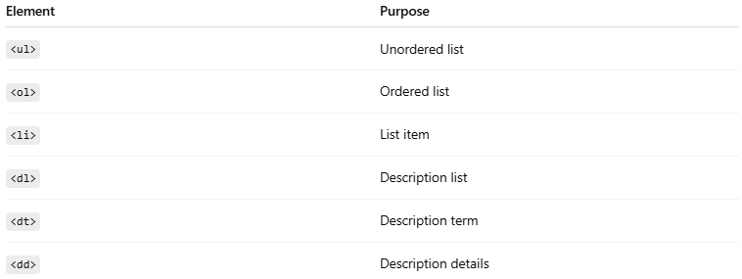
Element | Purpose
<ul> | Unordered list
<ol> | Ordered list
<li> | List item
<dl> | Description list
<dt> | Description term
<dd> | Description details

1. 🔸 Unordered List <ul>
# Source: AI Source: Provided by: [Data Path: Persons Table -> ID Column: 1, Name_En Column: Motasem Essam] -> From: [ChatGPT] on [5/6/2026]
📖 Description
Creates a bulleted list.
💻 Example:
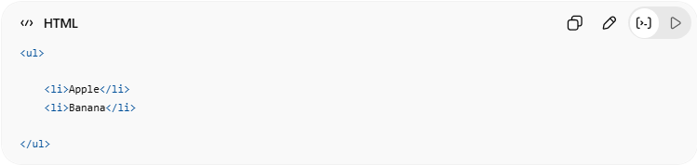
<ul>
<li>Apple</li>
<li>Banana</li>
</ul>
👉 Displays bullet points
🌐 Result
- Apple
- Banana

2. 🔢 Ordered List <ol>
# Source: AI Source: Provided by: [Data Path: Persons Table -> ID Column: 1, Name_En Column: Motasem Essam] -> From: [ChatGPT] on [5/6/2026]
📖 Description
Creates a numbered list.
💻 Example:
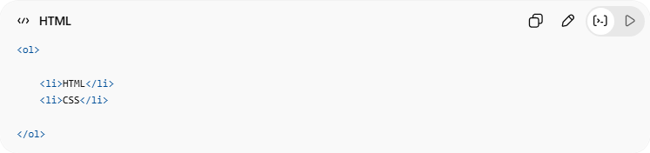
<ol>
<li>HTML</li>
<li>CSS</li>
</ol>
👉 Displays numbered items
🌐 Result
- HTML
- CSS

3. 📄 List Item <li>
# Source: AI Source: Provided by: [Data Path: Persons Table -> ID Column: 1, Name_En Column: Motasem Essam] -> From: [ChatGPT] on [5/6/2026]
📖 Description
Defines an item inside <ul> or <ol>.
💻 Example:
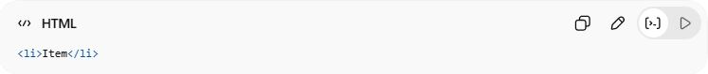
<li>Item</li>

4. 📚 Description List <dl>
# Source: AI Source: Provided by: [Data Path: Persons Table -> ID Column: 1, Name_En Column: Motasem Essam] -> From: [ChatGPT] on [5/6/2026]
📖 Description
Used for terms and descriptions.
💻 Example:
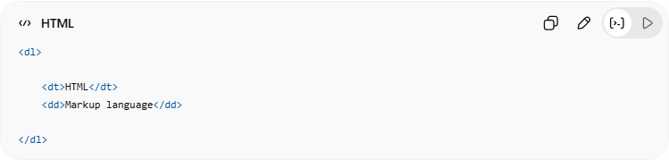
<dl>
<dt>HTML</dt>
<dd>Markup language</dd>
</dl>

5. 🏷️ Description Term <dt>
# Source: AI Source: Provided by: [Data Path: Persons Table -> ID Column: 1, Name_En Column: Motasem Essam] -> From: [ChatGPT] on [5/6/2026]
📖 Description
Defines the term/title.
💻 Example:
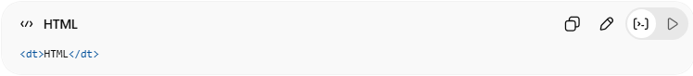
<dt>HTML</dt>

6. 📝 Description Details <dd>
# Source: AI Source: Provided by: [Data Path: Persons Table -> ID Column: 1, Name_En Column: Motasem Essam] -> From: [ChatGPT] on [5/6/2026]
📖 Description
Defines the description/details.
💻 Example:
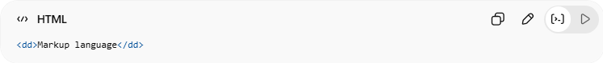
<dd>Markup language</dd>

💻 Example

Full Example
# Source: AI Source: Provided by: [Data Path: Persons Table -> ID Column: 1, Name_En Column: Motasem Essam] -> From: [ChatGPT] on [5/6/2026]
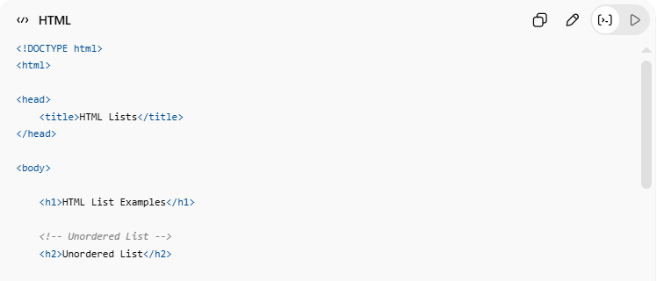
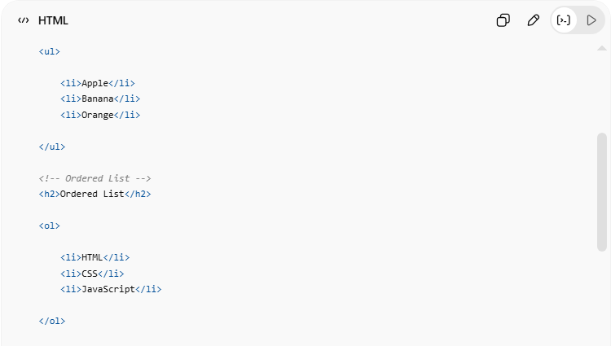
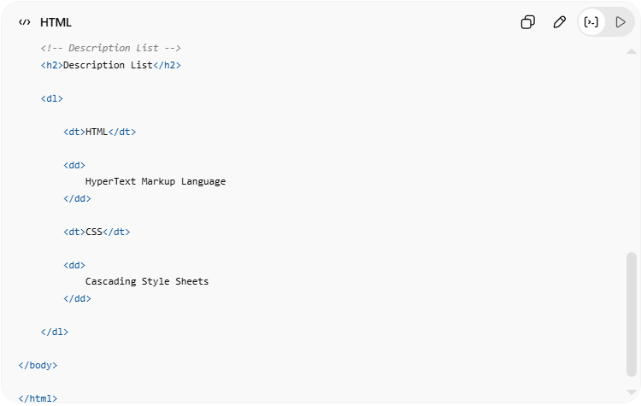
<!DOCTYPE html>
<html>
<head>
<title>HTML Lists</title>
</head>
<body>
<h1>HTML List Examples</h1>
<!-- Unordered List -->
<h2>Unordered List</h2>
<ul>
<li>Apple</li>
<li>Banana</li>
<li>Orange</li>
</ul>
<!-- Ordered List -->
<h2>Ordered List</h2>
<ol>
<li>HTML</li>
<li>CSS</li>
<li>JavaScript</li>
</ol>
<!-- Description List -->
<h2>Description List</h2>
<dl>
<dt>HTML</dt>
<dd>
HyperText Markup Language
</dd>
<dt>CSS</dt>
<dd>
Cascading Style Sheets
</dd>
</dl>
</body>
</html>

Real Example
# Source: ScreenShot Source: Provided by: [Persons Table -> ID Column: 1, Name_En Column: Motasem Essam] -> Tool: [Automation Table -> ID Column: 16, Name_En Column: Screen Capture] -> From [Operating System: Windows] on [5/6/2026]
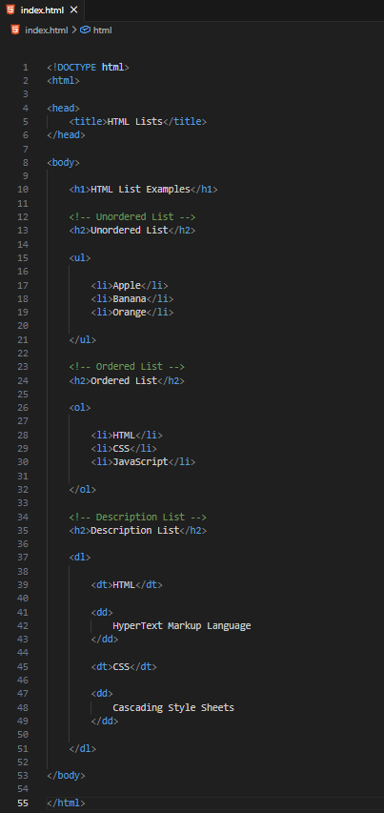
<!DOCTYPE html>
<html>

<head>
<title>HTML Lists</title>
</head>

<body>

<h1>HTML List Examples</h1>

<!-- Unordered List -->
<h2>Unordered List</h2>

<ul>

<li>Apple</li>
<li>Banana</li>
<li>Orange</li>

</ul>

<!-- Ordered List -->
<h2>Ordered List</h2>

<ol>

<li>HTML</li>
<li>CSS</li>
<li>JavaScript</li>

</ol>

<!-- Description List -->
<h2>Description List</h2>

<dl>

<dt>HTML</dt>

<dd>
HyperText Markup Language
</dd>

<dt>CSS</dt>

<dd>
Cascading Style Sheets
</dd>

</dl>

</body>

</html>
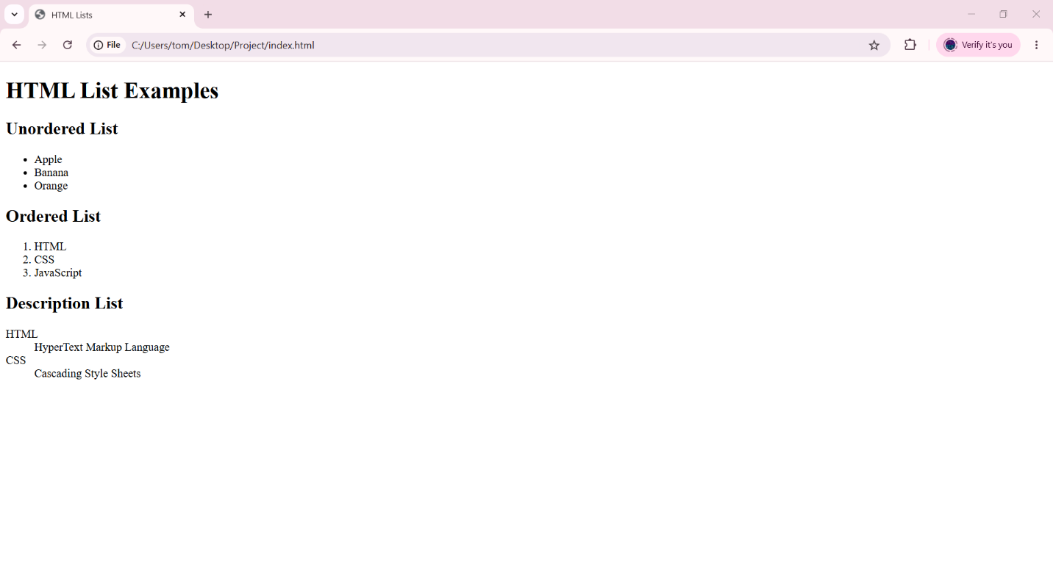

🧪 What You Can Test
# Source: AI Source: Provided by: [Data Path: Persons Table -> ID Column: 1, Name_En Column: Motasem Essam] -> From: [ChatGPT] on [5/6/2026]
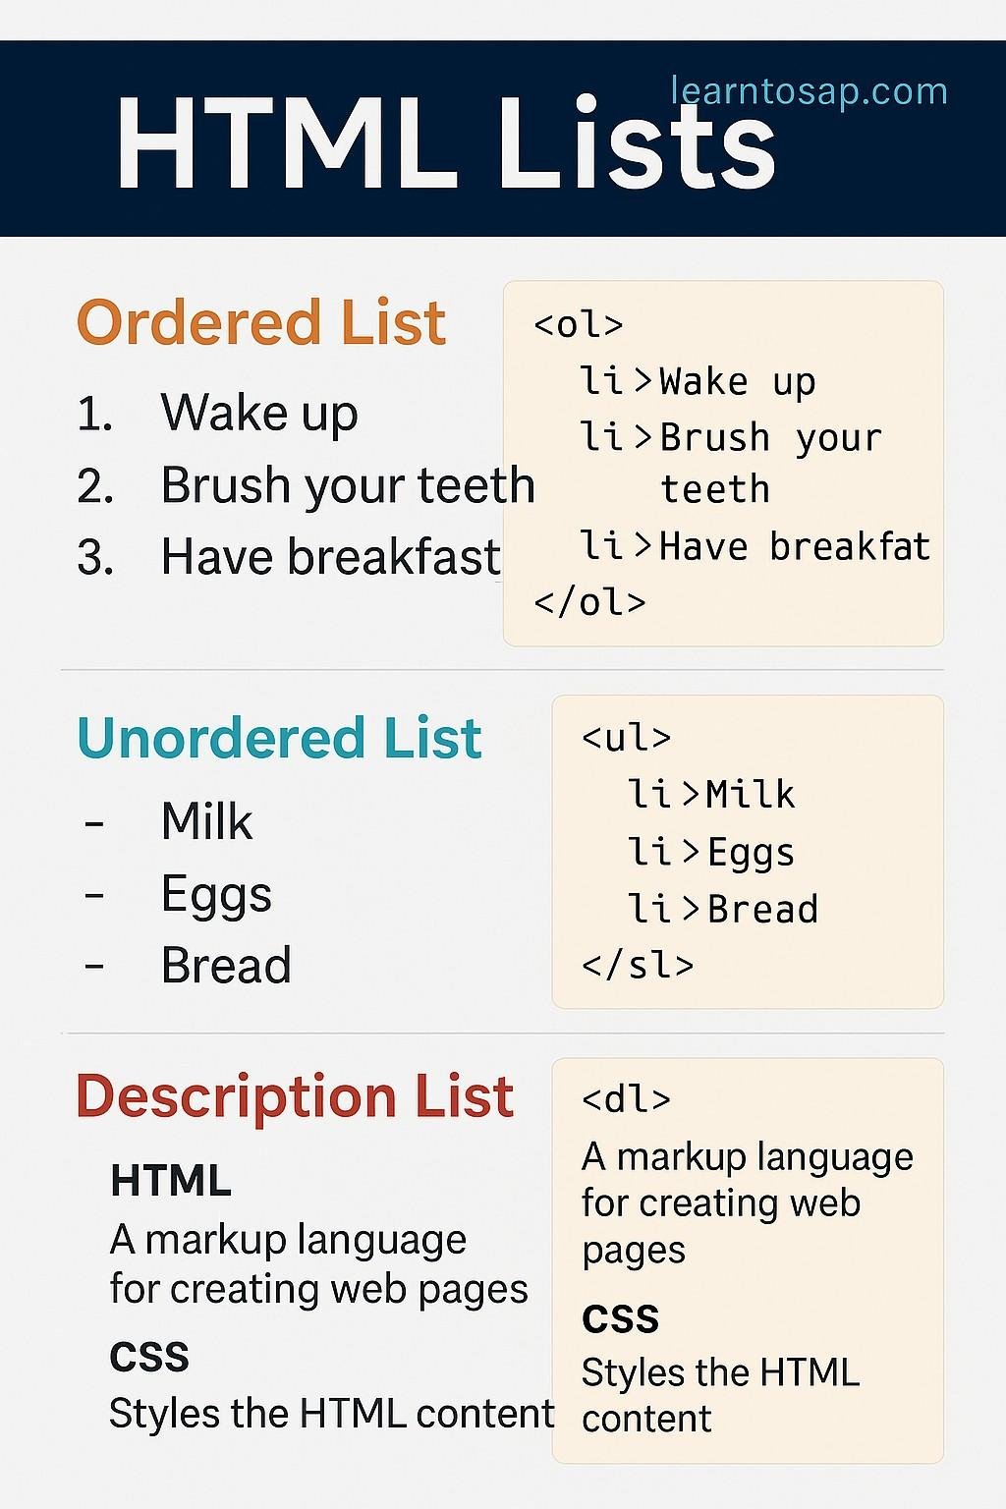
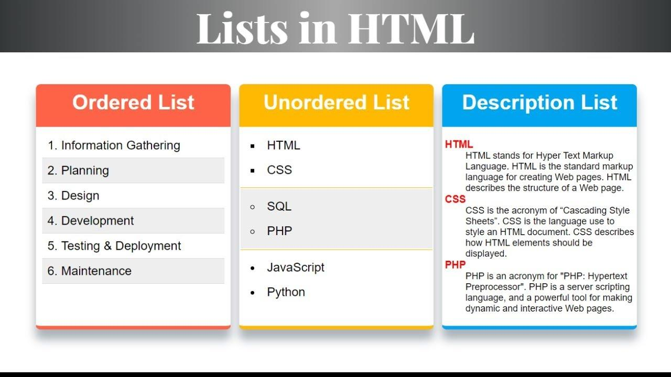
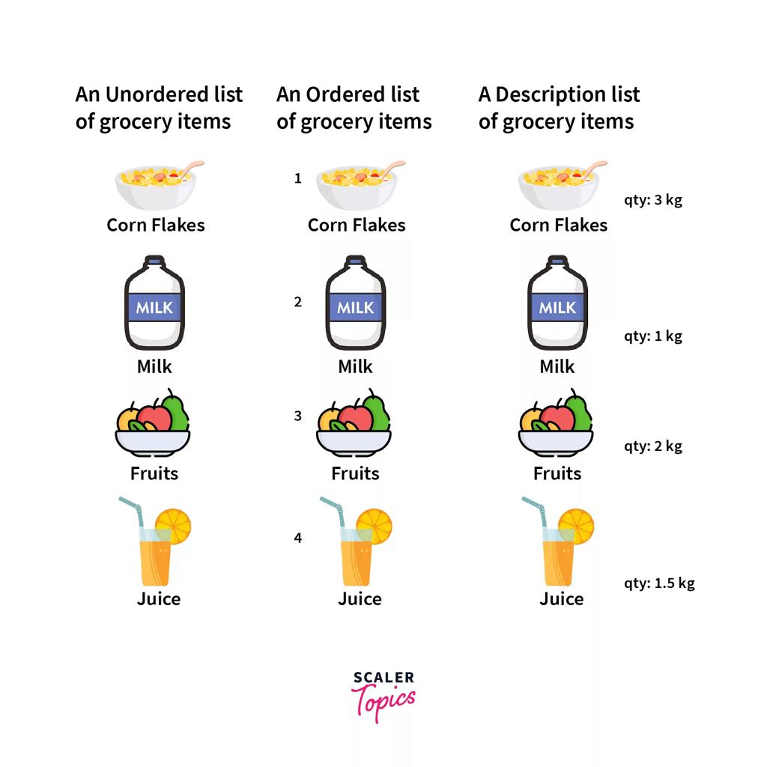
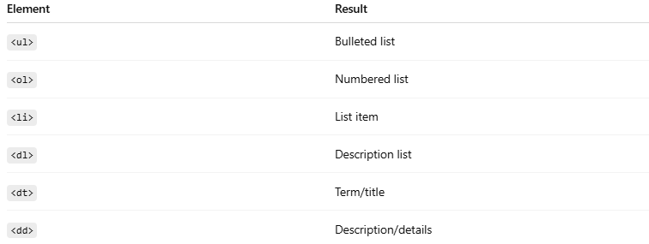
Element | Result
<ul> | Bulleted list
<ol> | Numbered list
<li> | List item
<dl> | Description list
<dt> | Term/title
<dd> | Description/details

🔸 HTML Unordered Lists

📘 Definition
# Source: AI Source: Provided by: [Data Path: Persons Table -> ID Column: 1, Name_En Column: Motasem Essam] -> From: [ChatGPT] on [5/6/2026]
An unordered list displays items with bullet markers.
It uses:
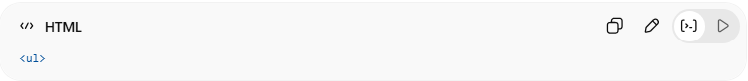
<ul>
with:
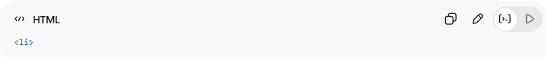
<li>
for list items.

🧠 Main Elements
# Source: AI Source: Provided by: [Data Path: Persons Table -> ID Column: 1, Name_En Column: Motasem Essam] -> From: [ChatGPT] on [5/6/2026]
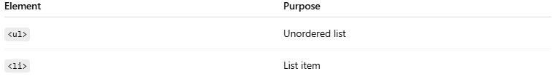
Element | Purpose
<ul> | Unordered list
<li> | List item

1. 📋 Unordered HTML List
# Source: AI Source: Provided by: [Data Path: Persons Table -> ID Column: 1, Name_En Column: Motasem Essam] -> From: [ChatGPT] on [5/6/2026]
📖 Description
Creates a basic bulleted list.
💻 Example:
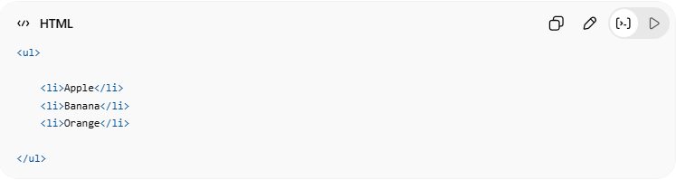
<ul>
<li>Apple</li>
<li>Banana</li>
<li>Orange</li>
</ul>
🌐 Result
- Apple
- Banana
- Orange

2. 🎯 Unordered HTML List — Choose List Item Marker
# Source: AI Source: Provided by: [Data Path: Persons Table -> ID Column: 1, Name_En Column: Motasem Essam] -> From: [ChatGPT] on [5/6/2026]
📖 Description
The bullet style can be changed using:
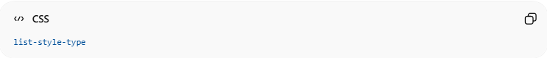
list-style-type

🔘 Disc Marker (Default)
# Source: AI Source: Provided by: [Data Path: Persons Table -> ID Column: 1, Name_En Column: Motasem Essam] -> From: [ChatGPT] on [5/6/2026]
💻 Example:
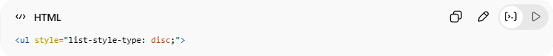
<ul style="list-style-type: disc;">
👉 Solid round bullets

⚪ Circle Marker
# Source: AI Source: Provided by: [Data Path: Persons Table -> ID Column: 1, Name_En Column: Motasem Essam] -> From: [ChatGPT] on [5/6/2026]
💻 Example:
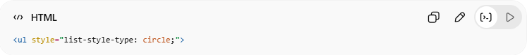
<ul style="list-style-type: circle;">
👉 Hollow circle bullets

⬛ Square Marker
# Source: AI Source: Provided by: [Data Path: Persons Table -> ID Column: 1, Name_En Column: Motasem Essam] -> From: [ChatGPT] on [5/6/2026]
💻 Example:
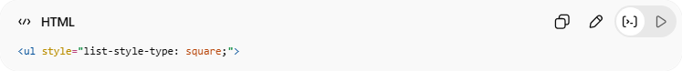
<ul style="list-style-type: square;">
👉 Square bullets

❌ No List Marker
# Source: AI Source: Provided by: [Data Path: Persons Table -> ID Column: 1, Name_En Column: Motasem Essam] -> From: [ChatGPT] on [5/6/2026]
💻 Example:
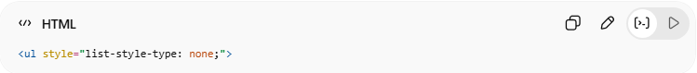
<ul style="list-style-type: none;">
👉 Removes bullets completely

3. 🧩 Nested HTML Lists
# Source: AI Source: Provided by: [Data Path: Persons Table -> ID Column: 1, Name_En Column: Motasem Essam] -> From: [ChatGPT] on [5/6/2026]
📖 Description
Lists can contain other lists inside list items.
💻 Example:
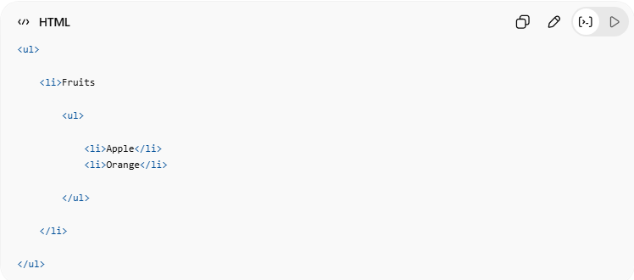
<ul>
<li>Fruits
<ul>
<li>Apple</li>
<li>Orange</li>
</ul>
</li>
</ul>
👉 Creates sub-lists

4. ↔️ Horizontal List with CSS
# Source: AI Source: Provided by: [Data Path: Persons Table -> ID Column: 1, Name_En Column: Motasem Essam] -> From: [ChatGPT] on [5/6/2026]
📖 Description
Lists can be displayed horizontally using CSS.
Usually used for:
- menus
- navigation bars
💻 Example:
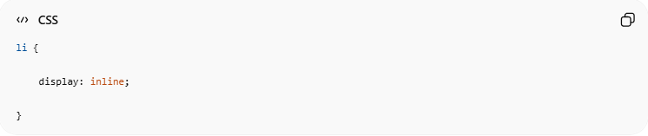
li {
display: inline;
}
👉 List items appear side-by-side

💻 Example

Full Example
# Source: AI Source: Provided by: [Data Path: Persons Table -> ID Column: 1, Name_En Column: Motasem Essam] -> From: [ChatGPT] on [5/6/2026]
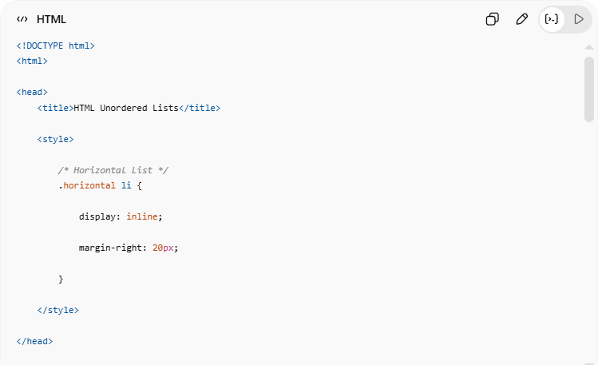
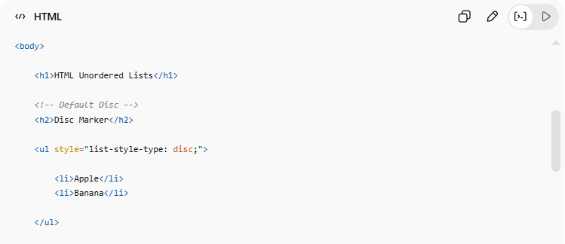
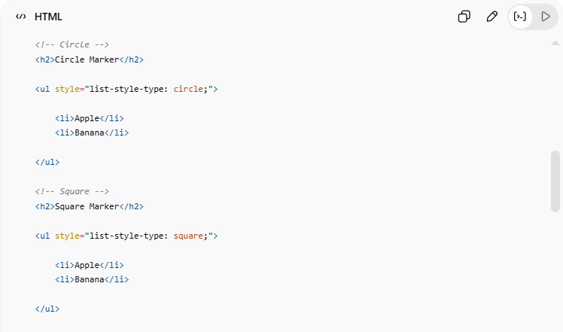
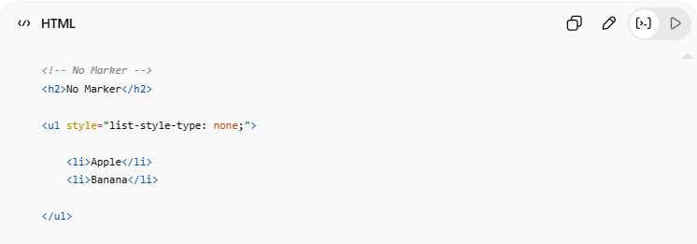
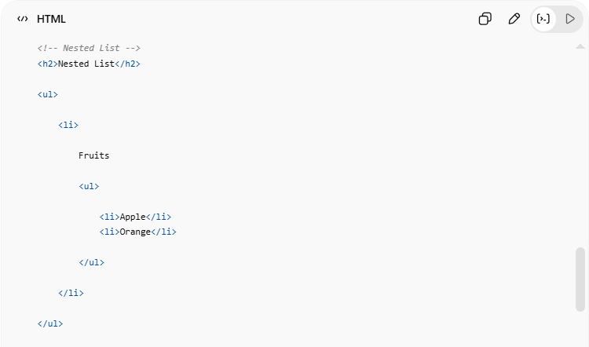
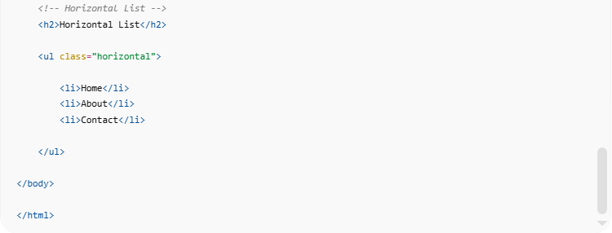

<!DOCTYPE html>
<html>
<head>
<title>HTML Unordered Lists</title>
<style>
/* Horizontal List */
.horizontal li {
display: inline;
margin-right: 20px;
}
</style>
</head>
<body>
<h1>HTML Unordered Lists</h1>
<!-- Default Disc -->
<h2>Disc Marker</h2>
<ul style="list-style-type: disc;">
<li>Apple</li>
<li>Banana</li>
</ul>
<!-- Circle -->
<h2>Circle Marker</h2>
<ul style="list-style-type: circle;">
<li>Apple</li>
<li>Banana</li>
</ul>
<!-- Square -->
<h2>Square Marker</h2>
<ul style="list-style-type: square;">
<li>Apple</li>
<li>Banana</li>
</ul>
<!-- No Marker -->
<h2>No Marker</h2>
<ul style="list-style-type: none;">
<li>Apple</li>
<li>Banana</li>
</ul>
<!-- Nested List -->
<h2>Nested List</h2>
<ul>
<li>
Fruits
<ul>
<li>Apple</li>
<li>Orange</li>
</ul>
</li>
</ul>
<!-- Horizontal List -->
<h2>Horizontal List</h2>
<ul class="horizontal">
<li>Home</li>
<li>About</li>
<li>Contact</li>
</ul>
</body>
</html>

Real Example
# Source: ScreenShot Source: Provided by: [Persons Table -> ID Column: 1, Name_En Column: Motasem Essam] -> Tool: [Automation Table -> ID Column: 16, Name_En Column: Screen Capture] -> From [Operating System: Windows] on [5/6/2026]
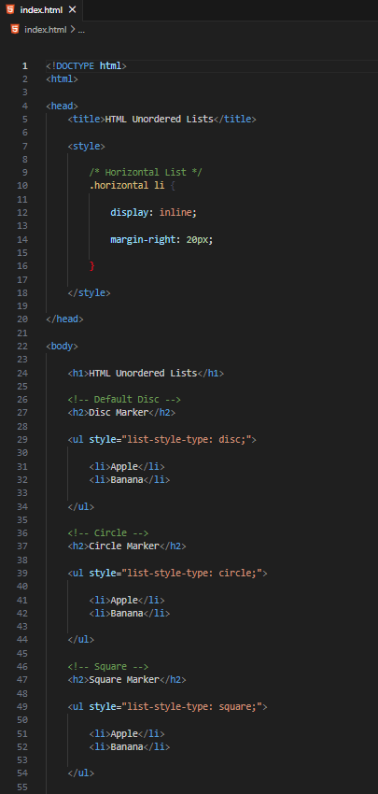
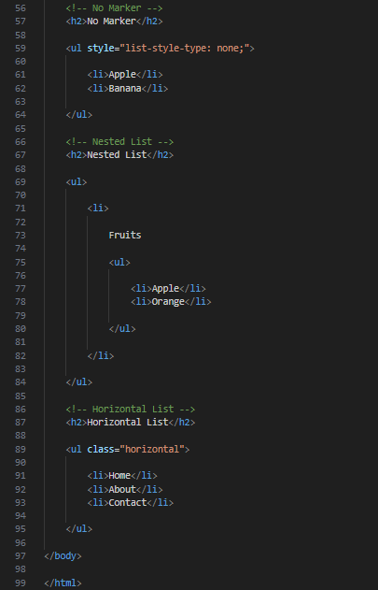
<!DOCTYPE html>
<html>

<head>
<title>HTML Unordered Lists</title>

<style>

/* Horizontal List */
.horizontal li {

display: inline;

margin-right: 20px;

}

</style>

</head>

<body>

<h1>HTML Unordered Lists</h1>

<!-- Default Disc -->
<h2>Disc Marker</h2>

<ul style="list-style-type: disc;">

<li>Apple</li>
<li>Banana</li>

</ul>

<!-- Circle -->
<h2>Circle Marker</h2>

<ul style="list-style-type: circle;">

<li>Apple</li>
<li>Banana</li>

</ul>

<!-- Square -->
<h2>Square Marker</h2>

<ul style="list-style-type: square;">

<li>Apple</li>
<li>Banana</li>

</ul>

<!-- No Marker -->
<h2>No Marker</h2>

<ul style="list-style-type: none;">

<li>Apple</li>
<li>Banana</li>

</ul>

<!-- Nested List -->
<h2>Nested List</h2>

<ul>

<li>

Fruits

<ul>

<li>Apple</li>
<li>Orange</li>

</ul>

</li>

</ul>

<!-- Horizontal List -->
<h2>Horizontal List</h2>

<ul class="horizontal">

<li>Home</li>
<li>About</li>
<li>Contact</li>

</ul>

</body>

</html>
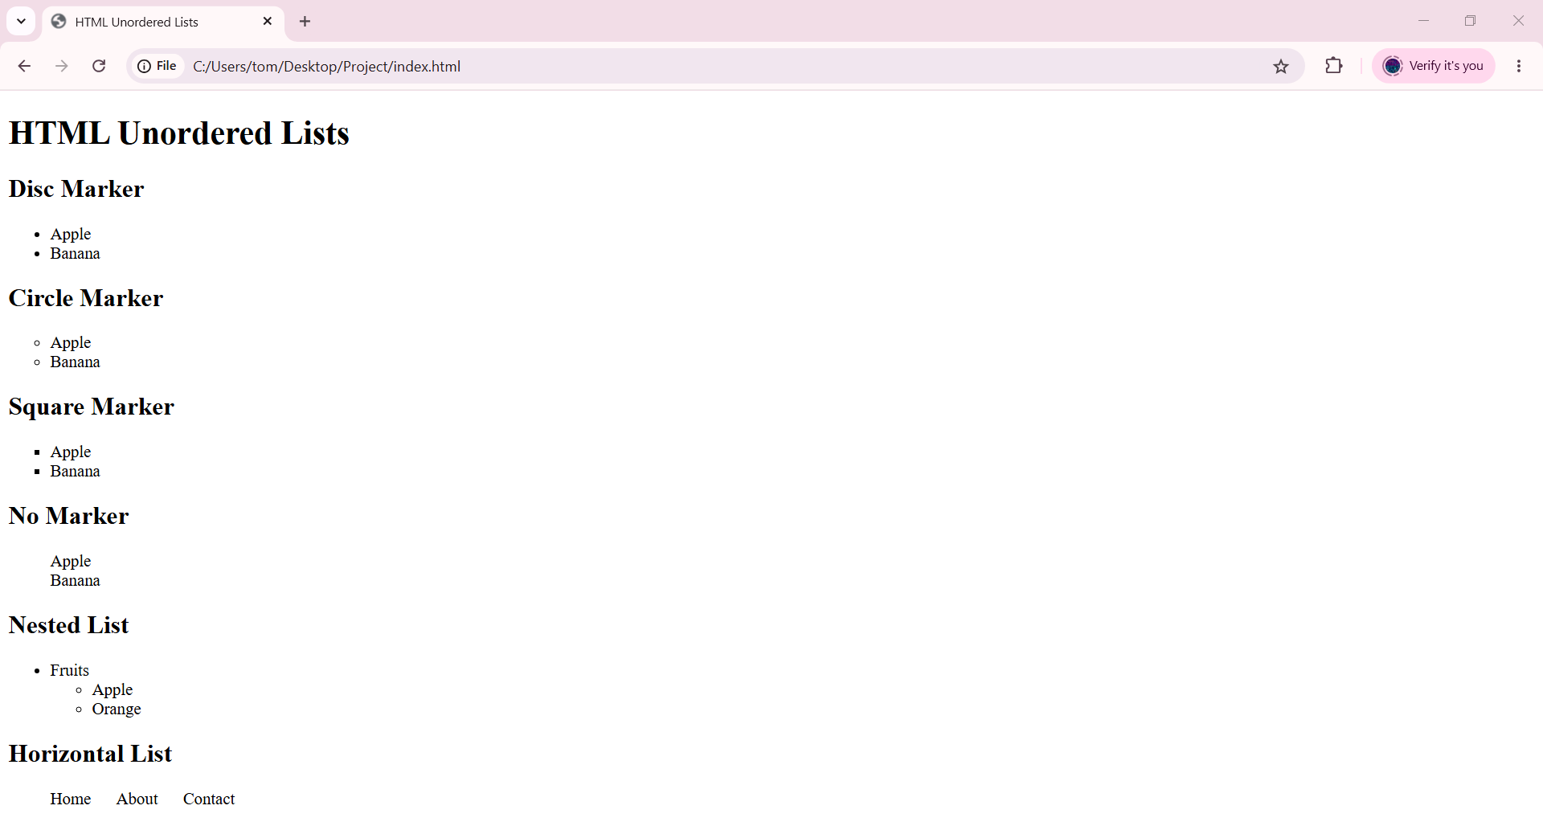

🧪 What You Can Test
# Source: AI Source: Provided by: [Data Path: Persons Table -> ID Column: 1, Name_En Column: Motasem Essam] -> From: [ChatGPT] on [5/6/2026]
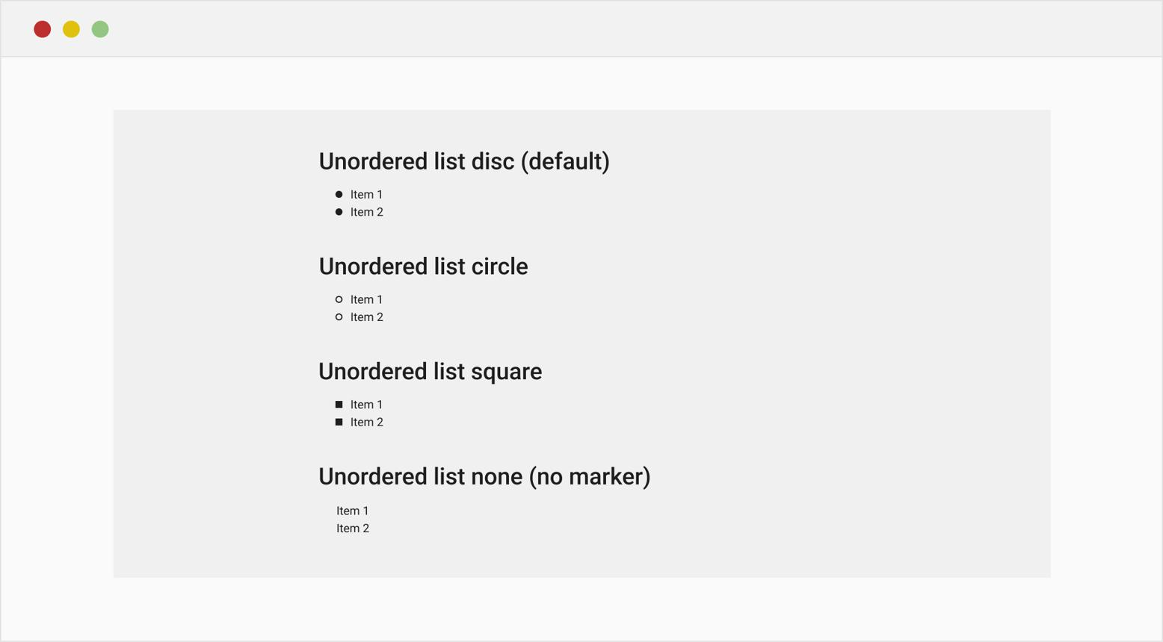
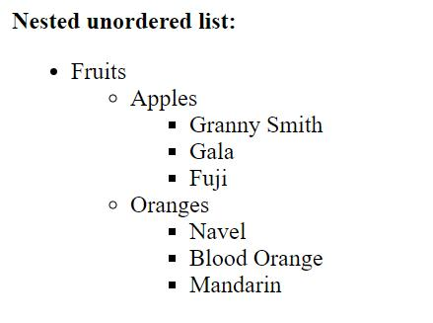
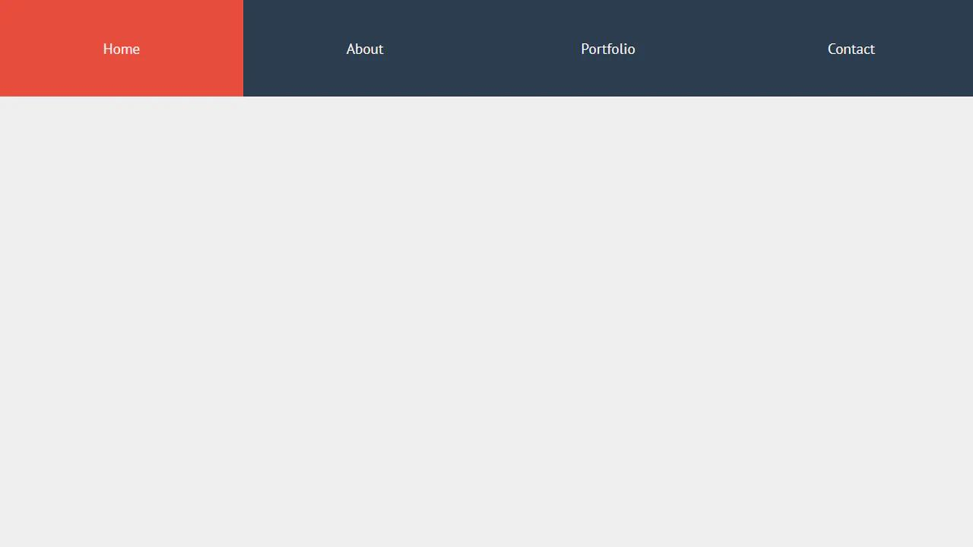
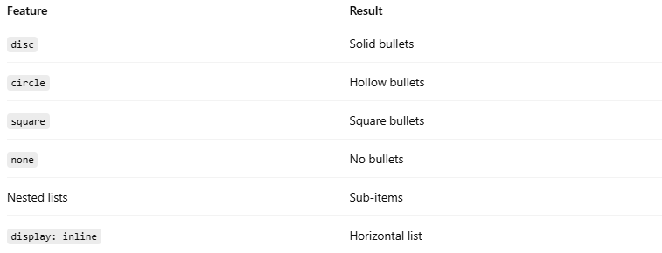
Feature | Result
disc | Solid bullets
circle | Hollow bullets
square | Square bullets
none | No bullets
Nested lists | Sub-items
display: inline | Horizontal list

⚠️ Important Notes

✅ Use nested lists for categories
# Source: AI Source: Provided by: [Data Path: Persons Table -> ID Column: 1, Name_En Column: Motasem Essam] -> From: [ChatGPT] on [5/6/2026]
👉 Creates hierarchy

✅ Horizontal lists are useful for menus
# Source: AI Source: Provided by: [Data Path: Persons Table -> ID Column: 1, Name_En Column: Motasem Essam] -> From: [ChatGPT] on [5/6/2026]
👉 Common in navigation bars

❌ Avoid excessive nesting
# Source: AI Source: Provided by: [Data Path: Persons Table -> ID Column: 1, Name_En Column: Motasem Essam] -> From: [ChatGPT] on [5/6/2026]
👉 Can reduce readability

🚀 In short:
# Source: AI Source: Provided by: [Data Path: Persons Table -> ID Column: 1, Name_En Column: Motasem Essam] -> From: [ChatGPT] on [5/6/2026]
HTML unordered lists use <ul> and <li> to display bulleted items with customizable markers, nested lists, and horizontal layouts.

🔢 HTML Ordered Lists
# Source: AI Source: Provided by: [Data Path: Persons Table -> ID Column: 1, Name_En Column: Motasem Essam] -> From: [ChatGPT] on [5/6/2026]
An ordered list displays items in a specific sequence using numbers or letters.
It uses:
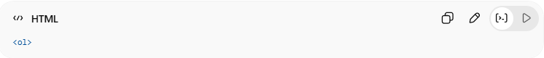
<ol>
with:
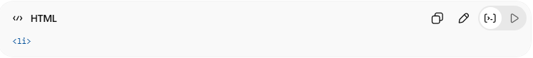
<li>
for list items.

🧠 Main Elements
# Source: AI Source: Provided by: [Data Path: Persons Table -> ID Column: 1, Name_En Column: Motasem Essam] -> From: [ChatGPT] on [5/6/2026]
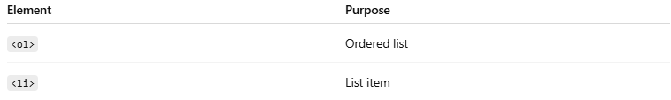
Element | Purpose
<ol> | Ordered list
<li> | List item

1. 📋 Ordered HTML List
# Source: AI Source: Provided by: [Data Path: Persons Table -> ID Column: 1, Name_En Column: Motasem Essam] -> From: [ChatGPT] on [5/6/2026]
📖 Description
Creates a numbered list.
💻 Example:
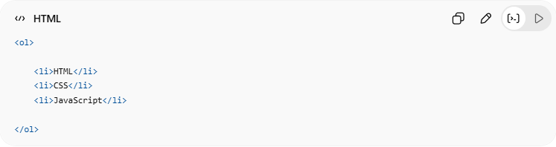
<ol>
<li>HTML</li>
<li>CSS</li>
<li>JavaScript</li>
</ol>
🌐 Result
- HTML
- CSS
- JavaScript

2. 🎯 Ordered HTML List — The type Attribute
# Source: AI Source: Provided by: [Data Path: Persons Table -> ID Column: 1, Name_En Column: Motasem Essam] -> From: [ChatGPT] on [5/6/2026]
📖 Description
The type attribute changes the numbering style.

🔢 Numbers (Default)
# Source: AI Source: Provided by: [Data Path: Persons Table -> ID Column: 1, Name_En Column: Motasem Essam] -> From: [ChatGPT] on [5/6/2026]
💻 Example:
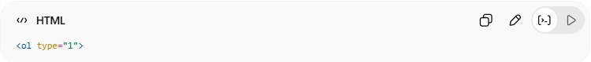
<ol type="1">
👉 1, 2, 3

🔠 Uppercase Letters
# Source: AI Source: Provided by: [Data Path: Persons Table -> ID Column: 1, Name_En Column: Motasem Essam] -> From: [ChatGPT] on [5/6/2026]
💻 Example:
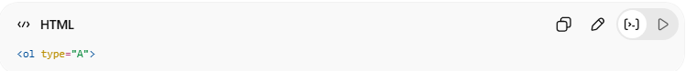
<ol type="A">
👉 A, B, C

🔡 Lowercase Letters
# Source: AI Source: Provided by: [Data Path: Persons Table -> ID Column: 1, Name_En Column: Motasem Essam] -> From: [ChatGPT] on [5/6/2026]
💻 Example:
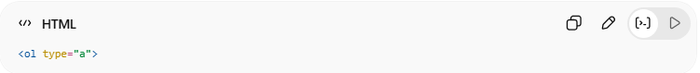
<ol type="a">
👉 a, b, c

🏛️ Roman Numbers — Uppercase
# Source: AI Source: Provided by: [Data Path: Persons Table -> ID Column: 1, Name_En Column: Motasem Essam] -> From: [ChatGPT] on [5/6/2026]
💻 Example:
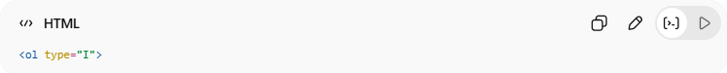
<ol type="I">
👉 I, II, III

🏺 Roman Numbers — Lowercase
# Source: AI Source: Provided by: [Data Path: Persons Table -> ID Column: 1, Name_En Column: Motasem Essam] -> From: [ChatGPT] on [5/6/2026]
💻 Example:
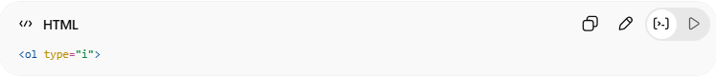
<ol type="i">
👉 i, ii, iii

3. 🎛️ Control List Counting
# Source: AI Source: Provided by: [Data Path: Persons Table -> ID Column: 1, Name_En Column: Motasem Essam] -> From: [ChatGPT] on [5/6/2026]
📖 Description
The start attribute changes the starting number.
💻 Example:
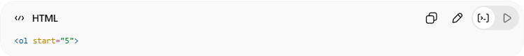
<ol start="5">
👉 Starts counting from 5
🌐 Result
- HTML
- CSS

4. 🧩 Nested HTML Lists
# Source: AI Source: Provided by: [Data Path: Persons Table -> ID Column: 1, Name_En Column: Motasem Essam] -> From: [ChatGPT] on [5/6/2026]
📖 Description
Lists can contain other lists inside list items.
💻 Example:
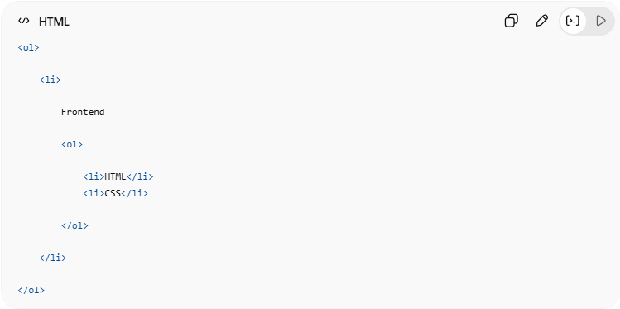
<ol>
<li>
Frontend
<ol>
<li>HTML</li>
<li>CSS</li>
</ol>
</li>
</ol>
👉 Creates sub-lists

💻 Example

Full Example
# Source: AI Source: Provided by: [Data Path: Persons Table -> ID Column: 1, Name_En Column: Motasem Essam] -> From: [ChatGPT] on [5/6/2026]
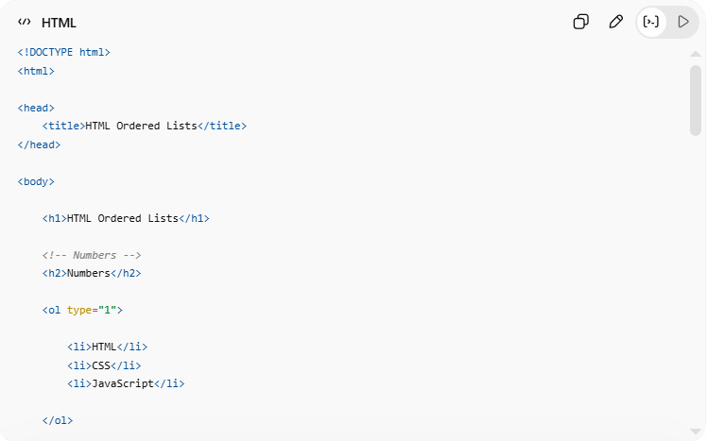
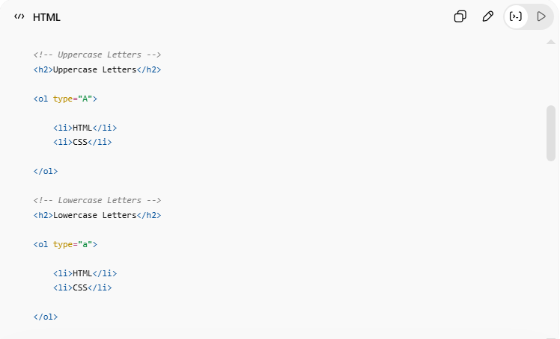
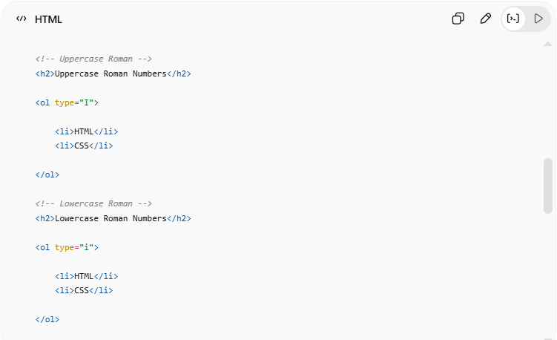
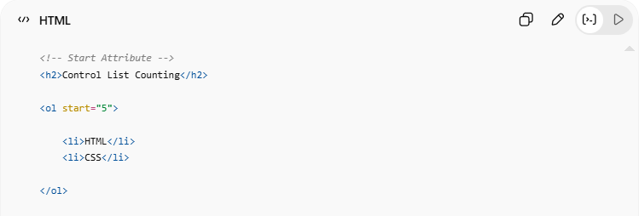
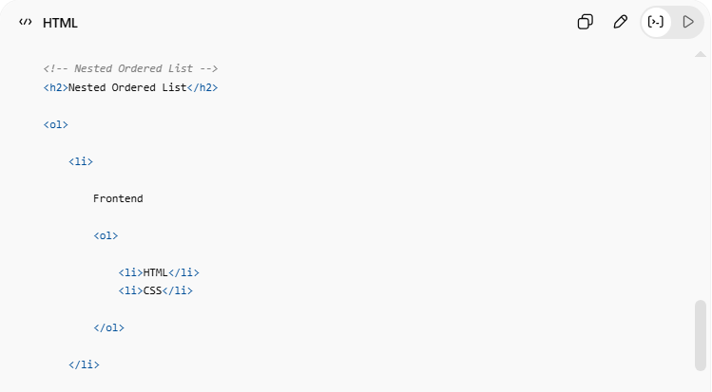
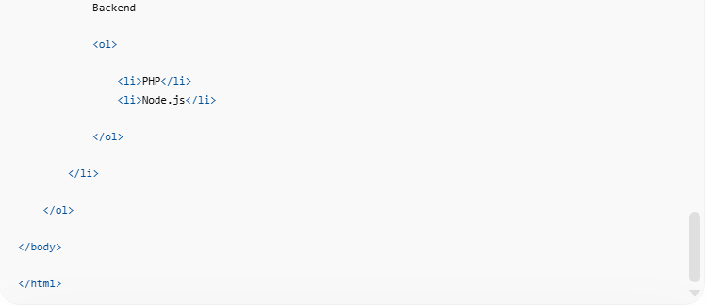
<!DOCTYPE html>
<html>
<head>
<title>HTML Ordered Lists</title>
</head>
<body>
<h1>HTML Ordered Lists</h1>
<!-- Numbers -->
<h2>Numbers</h2>
<ol type="1">
<li>HTML</li>
<li>CSS</li>
<li>JavaScript</li>
</ol>
<!-- Uppercase Letters -->
<h2>Uppercase Letters</h2>
<ol type="A">
<li>HTML</li>
<li>CSS</li>
</ol>
<!-- Lowercase Letters -->
<h2>Lowercase Letters</h2>
<ol type="a">
<li>HTML</li>
<li>CSS</li>
</ol>
<!-- Uppercase Roman -->
<h2>Uppercase Roman Numbers</h2>
<ol type="I">
<li>HTML</li>
<li>CSS</li>
</ol>
<!-- Lowercase Roman -->
<h2>Lowercase Roman Numbers</h2>
<ol type="i">
<li>HTML</li>
<li>CSS</li>
</ol>
<!-- Start Attribute -->
<h2>Control List Counting</h2>
<ol start="5">
<li>HTML</li>
<li>CSS</li>
</ol>
<!-- Nested Ordered List -->
<h2>Nested Ordered List</h2>
<ol>
<li>
Frontend
<ol>
<li>HTML</li>
<li>CSS</li>
</ol>
</li>
<li>
Backend
<ol>
<li>PHP</li>
<li>Node.js</li>
</ol>
</li>
</ol>
</body>
</html>

Real Example
# Source: ScreenShot Source: Provided by: [Persons Table -> ID Column: 1, Name_En Column: Motasem Essam] -> Tool: [Automation Table -> ID Column: 16, Name_En Column: Screen Capture] -> From [Operating System: Windows] on [5/6/2026]
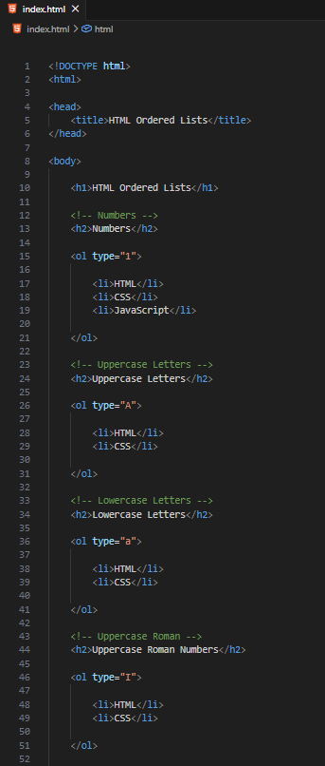
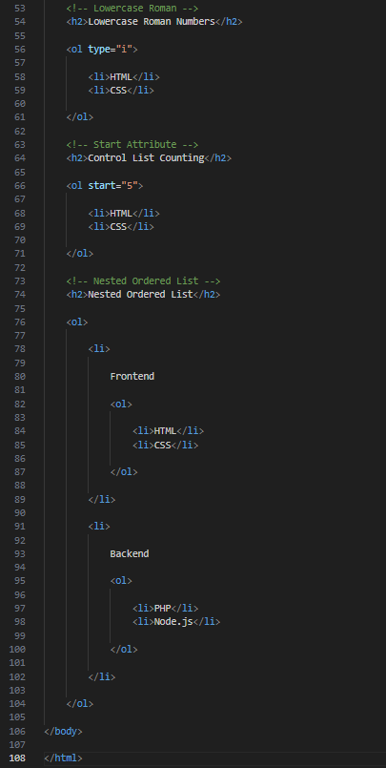
<!DOCTYPE html>
<html>

<head>
<title>HTML Ordered Lists</title>
</head>

<body>

<h1>HTML Ordered Lists</h1>

<!-- Numbers -->
<h2>Numbers</h2>

<ol type="1">

<li>HTML</li>
<li>CSS</li>
<li>JavaScript</li>

</ol>

<!-- Uppercase Letters -->
<h2>Uppercase Letters</h2>

<ol type="A">

<li>HTML</li>
<li>CSS</li>

</ol>

<!-- Lowercase Letters -->
<h2>Lowercase Letters</h2>

<ol type="a">

<li>HTML</li>
<li>CSS</li>

</ol>

<!-- Uppercase Roman -->
<h2>Uppercase Roman Numbers</h2>

<ol type="I">

<li>HTML</li>
<li>CSS</li>

</ol>

<!-- Lowercase Roman -->
<h2>Lowercase Roman Numbers</h2>

<ol type="i">

<li>HTML</li>
<li>CSS</li>

</ol>

<!-- Start Attribute -->
<h2>Control List Counting</h2>

<ol start="5">

<li>HTML</li>
<li>CSS</li>

</ol>

<!-- Nested Ordered List -->
<h2>Nested Ordered List</h2>

<ol>

<li>

Frontend

<ol>

<li>HTML</li>
<li>CSS</li>

</ol>

</li>

<li>

Backend

<ol>

<li>PHP</li>
<li>Node.js</li>

</ol>

</li>

</ol>

</body>

</html>
# Source: GIF Source: Provided by: [Persons Table -> ID Column: 1, Name_En Column: Motasem Essam] -> Tool: [Automation Table -> ID Column: 17, Name_En Column: GIF Recorder] -> From [Operating System: Windows] on [5/6/2026]


🧪 What You Can Test
# Source: AI Source: Provided by: [Data Path: Persons Table -> ID Column: 1, Name_En Column: Motasem Essam] -> From: [ChatGPT] on [5/6/2026]
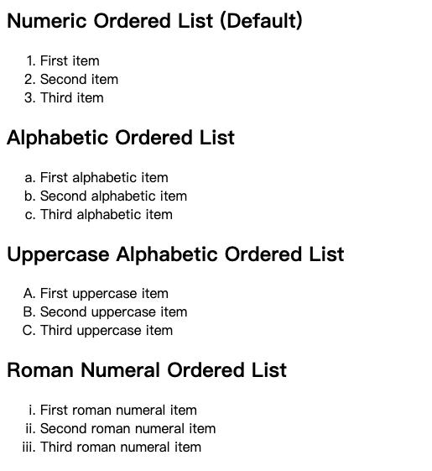
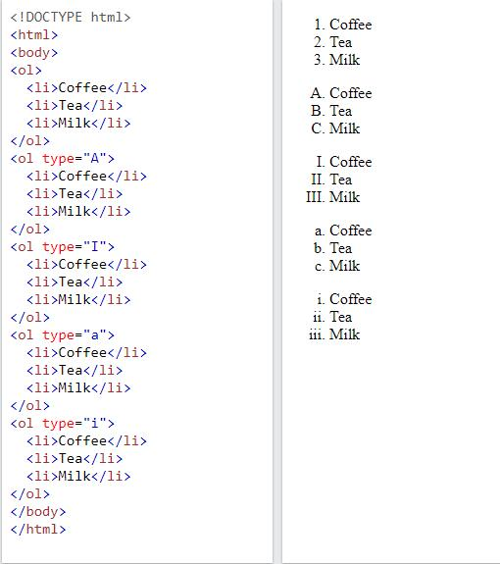
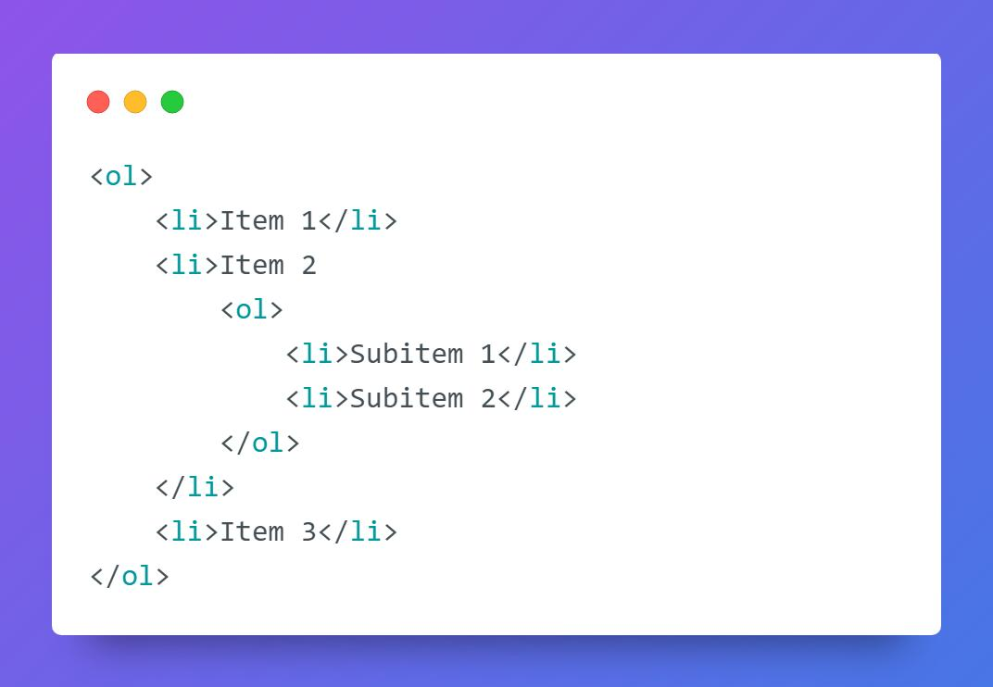
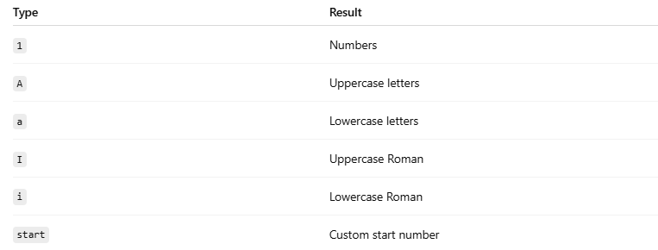
Type | Result
1 | Numbers
A | Uppercase letters
a | Lowercase letters
I | Uppercase Roman
i | Lowercase Roman
start | Custom start number

⚠️ Important Notes

✅ Ordered lists are useful for sequences
# Source: AI Source: Provided by: [Data Path: Persons Table -> ID Column: 1, Name_En Column: Motasem Essam] -> From: [ChatGPT] on [5/6/2026]
👉 Steps, instructions, rankings

✅ type changes numbering style
# Source: AI Source: Provided by: [Data Path: Persons Table -> ID Column: 1, Name_En Column: Motasem Essam] -> From: [ChatGPT] on [5/6/2026]
👉 Numbers, letters, Roman numerals

✅ start changes counting start value
# Source: AI Source: Provided by: [Data Path: Persons Table -> ID Column: 1, Name_En Column: Motasem Essam] -> From: [ChatGPT] on [5/6/2026]
👉 Useful for continued lists

❌ Avoid deep nesting
# Source: AI Source: Provided by: [Data Path: Persons Table -> ID Column: 1, Name_En Column: Motasem Essam] -> From: [ChatGPT] on [5/6/2026]
👉 Can become difficult to read

🚀 In short:
# Source: AI Source: Provided by: [Data Path: Persons Table -> ID Column: 1, Name_En Column: Motasem Essam] -> From: [ChatGPT] on [5/6/2026]
HTML ordered lists use <ol> and <li> to display numbered items with customizable numbering styles and nested structures.

📚 HTML Other Lists

🏷️ HTML Description Lists
# Source: AI Source: Provided by: [Data Path: Persons Table -> ID Column: 1, Name_En Column: Motasem Essam] -> From: [ChatGPT] on [5/6/2026]
A description list is used to display:
- terms
- names
- titles
with their descriptions.
It is commonly used for:
- dictionaries
- glossaries
- FAQs
- definitions

🧠 Main Elements
# Source: AI Source: Provided by: [Data Path: Persons Table -> ID Column: 1, Name_En Column: Motasem Essam] -> From: [ChatGPT] on [5/6/2026]
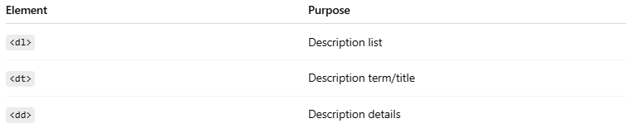
Element | Purpose
<dl> | Description list
<dt> | Description term/title
<dd> | Description details

1. 📋 <dl> — Description List
# Source: AI Source: Provided by: [Data Path: Persons Table -> ID Column: 1, Name_En Column: Motasem Essam] -> From: [ChatGPT] on [5/6/2026]
📖 Description
Creates the main description list container.
💻 Example:
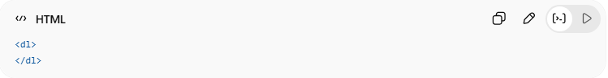
<dl>
</dl>

2. 🏷️ <dt> — Description Term
# Source: AI Source: Provided by: [Data Path: Persons Table -> ID Column: 1, Name_En Column: Motasem Essam] -> From: [ChatGPT] on [5/6/2026]
📖 Description
Defines the term or title.
💻 Example:
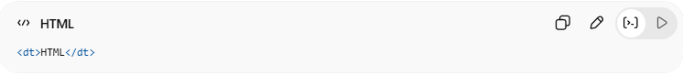
<dt>HTML</dt>
👉 Displays the item name

3. 📝 <dd> — Description Details
# Source: AI Source: Provided by: [Data Path: Persons Table -> ID Column: 1, Name_En Column: Motasem Essam] -> From: [ChatGPT] on [5/6/2026]
📖 Description
Defines the description/details for the term.
💻 Example:
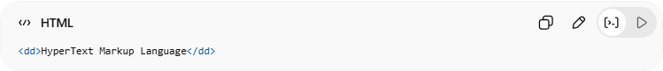
<dd>HyperText Markup Language</dd>
👉 Displays explanation/details
🌐 Basic Example
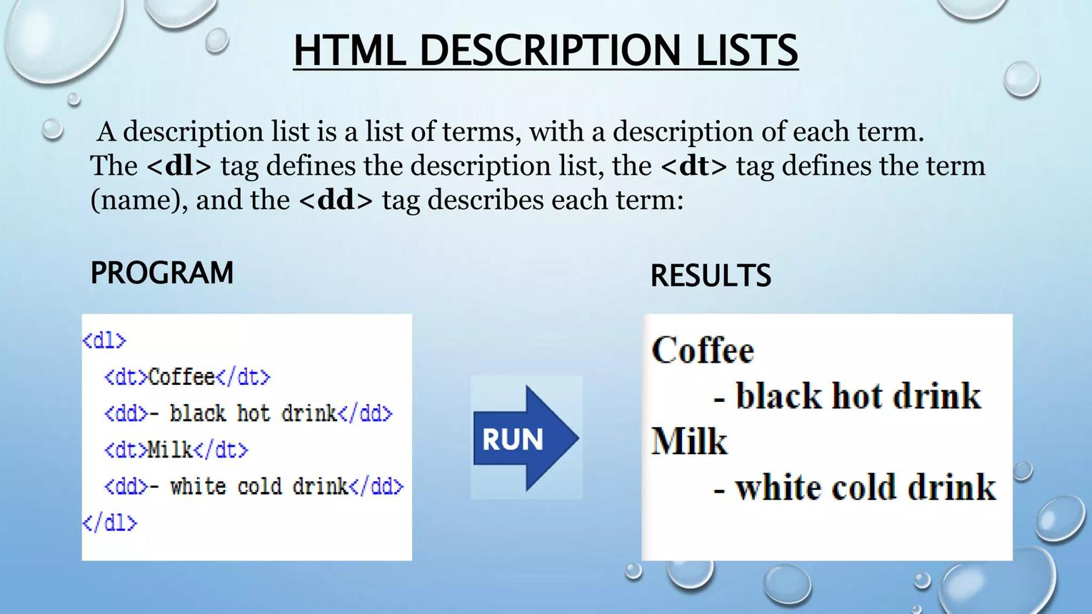
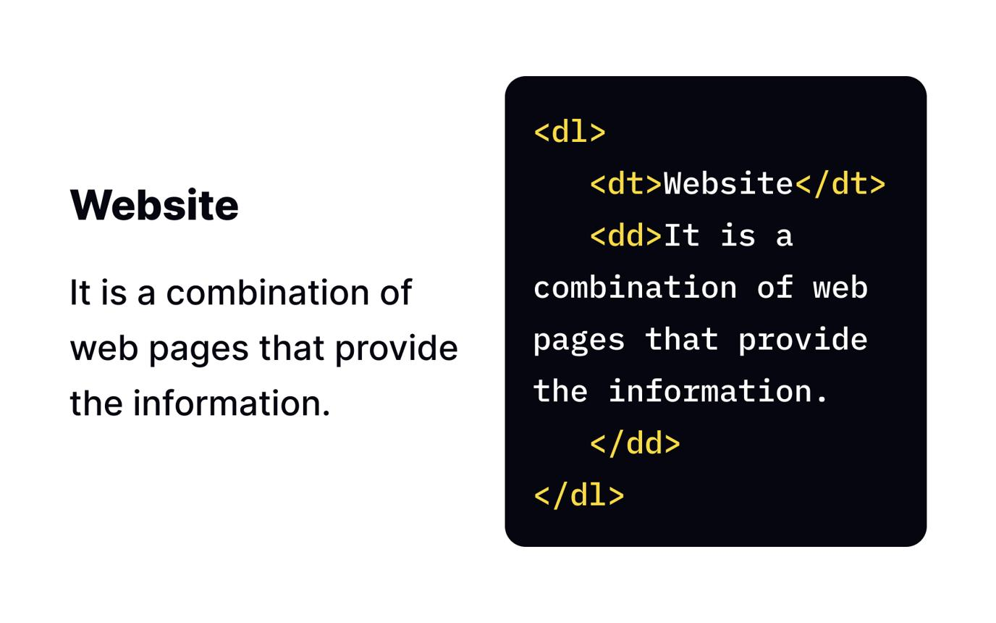
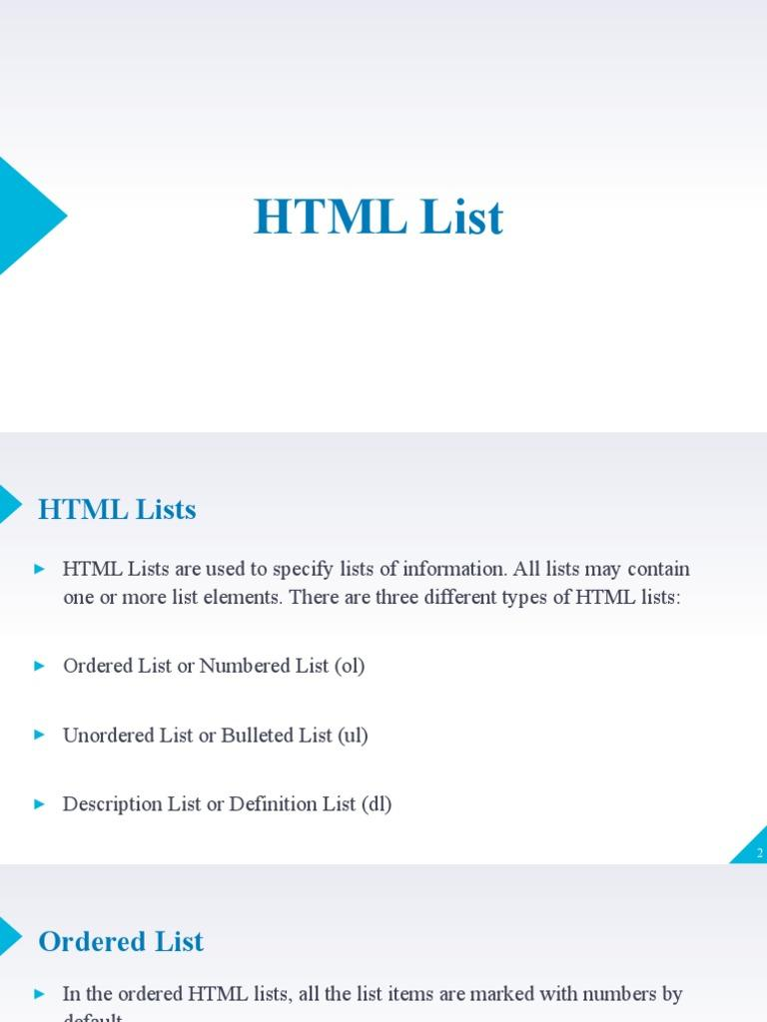
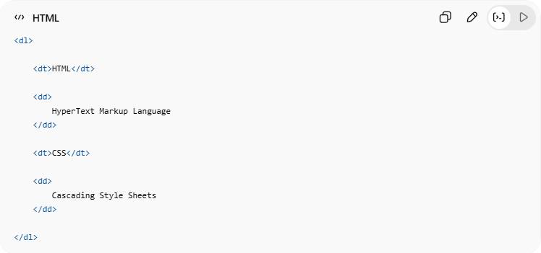
<dl>
<dt>HTML</dt>
<dd>
HyperText Markup Language
</dd>
<dt>CSS</dt>
<dd>
Cascading Style Sheets
</dd>
</dl>

💻 Example

Full Example
# Source: AI Source: Provided by: [Data Path: Persons Table -> ID Column: 1, Name_En Column: Motasem Essam] -> From: [ChatGPT] on [5/6/2026]
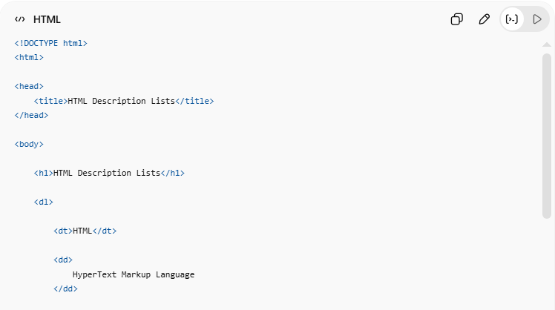
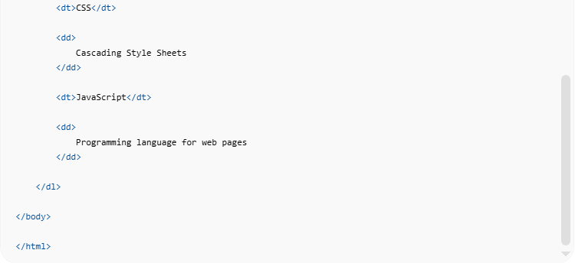
<!DOCTYPE html>
<html>
<head>
<title>HTML Description Lists</title>
</head>
<body>
<h1>HTML Description Lists</h1>
<dl>
<dt>HTML</dt>
<dd>
HyperText Markup Language
</dd>
<dt>CSS</dt>
<dd>
Cascading Style Sheets
</dd>
<dt>JavaScript</dt>
<dd>
Programming language for web pages
</dd>
</dl>
</body>
</html>

Real Example
# Source: ScreenShot Source: Provided by: [Persons Table -> ID Column: 1, Name_En Column: Motasem Essam] -> Tool: [Automation Table -> ID Column: 16, Name_En Column: Screen Capture] -> From [Operating System: Windows] on [5/6/2026]
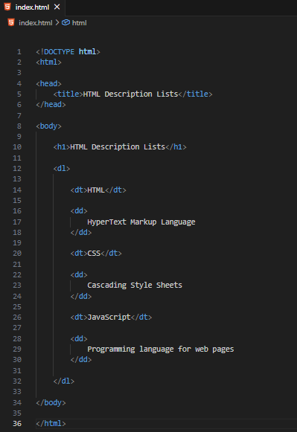
<!DOCTYPE html>
<html>

<head>
<title>HTML Description Lists</title>
</head>

<body>

<h1>HTML Description Lists</h1>

<dl>

<dt>HTML</dt>

<dd>
HyperText Markup Language
</dd>

<dt>CSS</dt>

<dd>
Cascading Style Sheets
</dd>

<dt>JavaScript</dt>

<dd>
Programming language for web pages
</dd>

</dl>

</body>

</html>
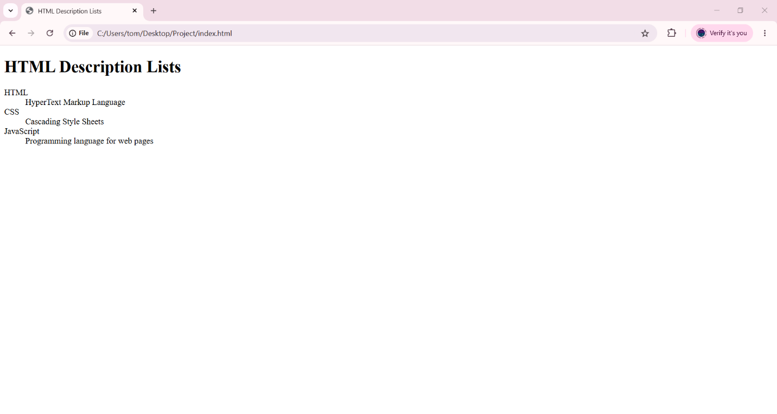

🧪 What You Can Test
# Source: AI Source: Provided by: [Data Path: Persons Table -> ID Column: 1, Name_En Column: Motasem Essam] -> From: [ChatGPT] on [5/6/2026]
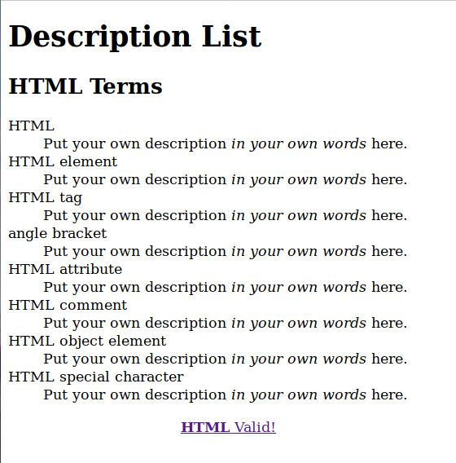
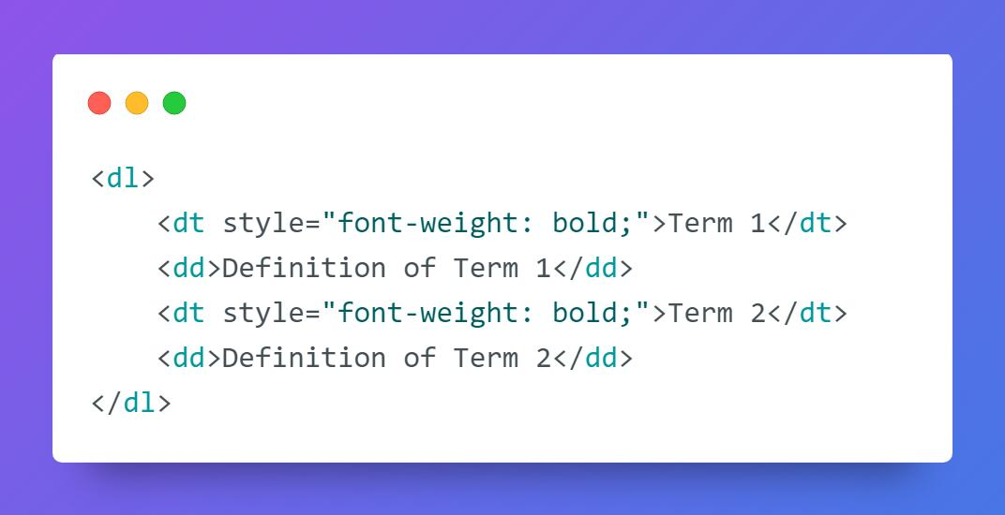
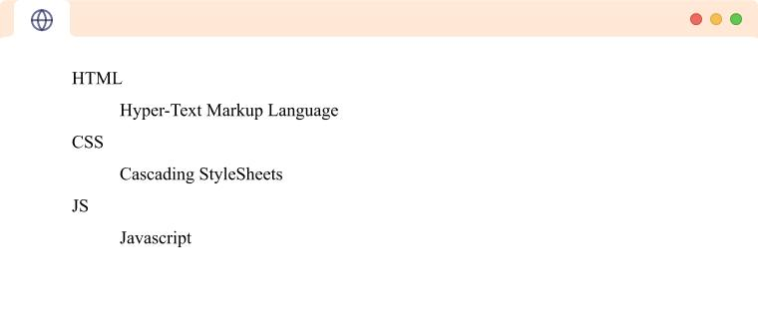
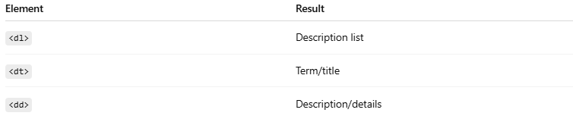
Element | Result
<dl> | Description list
<dt> | Term/title
<dd> | Description/details

⚠️ Important Notes

✅ Use description lists for definitions
# Source: AI Source: Provided by: [Data Path: Persons Table -> ID Column: 1, Name_En Column: Motasem Essam] -> From: [ChatGPT] on [5/6/2026]
👉 Better semantic meaning

✅ One <dt> can have multiple <dd>
# Source: AI Source: Provided by: [Data Path: Persons Table -> ID Column: 1, Name_En Column: Motasem Essam] -> From: [ChatGPT] on [5/6/2026]
💻 Example:
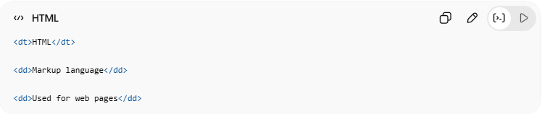
<dt>HTML</dt>
<dd>Markup language</dd>
<dd>Used for web pages</dd>

❌ Do not use <dl> for navigation menus
# Source: AI Source: Provided by: [Data Path: Persons Table -> ID Column: 1, Name_En Column: Motasem Essam] -> From: [ChatGPT] on [5/6/2026]
👉 Use:
- <ul>
- <ol>
instead

🚀 In short:
HTML description lists use <dl>, <dt>, and <dd> to display terms and their descriptions in a semantic structure.

⚠️ Important Notes

✅ <li> must be inside <ul> or <ol>
# Source: AI Source: Provided by: [Data Path: Persons Table -> ID Column: 1, Name_En Column: Motasem Essam] -> From: [ChatGPT] on [5/6/2026]
👉 Required for valid lists

✅ Use ordered lists for sequences
# Source: AI Source: Provided by: [Data Path: Persons Table -> ID Column: 1, Name_En Column: Motasem Essam] -> From: [ChatGPT] on [5/6/2026]
👉 Steps, rankings, instructions

✅ Use unordered lists for grouped items
# Source: AI Source: Provided by: [Data Path: Persons Table -> ID Column: 1, Name_En Column: Motasem Essam] -> From: [ChatGPT] on [5/6/2026]
👉 Menus, categories, collections

✅ Description lists are useful for definitions
# Source: AI Source: Provided by: [Data Path: Persons Table -> ID Column: 1, Name_En Column: Motasem Essam] -> From: [ChatGPT] on [5/6/2026]
👉 Dictionaries, FAQs, glossaries

🚀 In short:
# Source: AI Source: Provided by: [Data Path: Persons Table -> ID Column: 1, Name_En Column: Motasem Essam] -> From: [ChatGPT] on [5/6/2026]
HTML lists organize information using unordered lists, ordered lists, and description lists.

